Week In Review September 13 - September 26, 2001
Alex Shvartsman

New York: Aftermath

I would like to thank everyone for the amount of support they showed me and other New York players in the aftermath of the September 11 tragedy. Everyone is recovering as best they can. New York businesses have been hard-hit though, including Neutral Ground. NG has asked for help from the players who read and enjoy its web site. You can find the details here.

Grand Prix-Oslo
For the first time in years, Sideboard was unable to offer live coverage of a Grand Prix. This had to do with server problems that plagued the site for close to a week. Fortunately, veteran Sideboard reporter Kim Eikefet came to the rescue. A Norwegian player herself, Eikefet posted tournament coverage at mtgnorway.no.
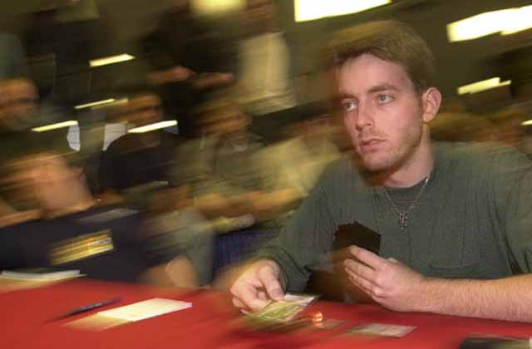
No North American players traveled to GP-Olso, making it also the first GP in years without the presence of any U.S. players. It was partly due to the tragic events of Setpember 11, partly due to the format, and partly to the high cost of airfare. Regardless, Oslo gathered about 300 players from a number of European countries.
Domain decks were out in force, and many Domain players advanced to Day 2. However, the deck's performance on Day 2 was suboptimal as the metagame was now prepared for the Domain threat. Budde himself barely missed placing in the money, finishing 33rd. Instead, the tournament was dominated by various versions of blue-black-white control. Varying between GoMar (much changed from the version Ryan Fuller used to win GP-Moscow), to variants of NoMar (Dragonless control) and Desolation Angel-based discard decks. It was Denmark's Trey Van Cleave who won the top prize, with a b-w-u version designed by Louvre Crnobori. Crnobori was also the player who earlier designed the b-w-u version Sigurd Eskeland used to re-qualify for the Pro Tour and Dave Williams used to go undefeated through Day 1 of GP-London. Do we have a new deck guru on our hands? Pro Tour-New Orleans may be the test of that.
Van Cleave is now one of a very small group of people to have won three Grand Prix. Budde is leading the pack with four wins.
Eskeland too made Top 8 of GP-Olso. Strangely, he was using a blue-green-red aggro deck, despite his strong appreciation for the Desolation Angel strategy. In an interview, Eskeland admitted he would have played a different deck if he had to do it all over again. Nevertheless, his result was definitely solid, placing him in the top 4 of the tournament.

Odyssey Prerelease

While top European players fought it out at GP-Oslo, the rest of us had an opportunity to sample the brand-new set. Threshhold and flashback mechanics seem to land themselves really well to Limited play, promising an interesting few weeks ahead as players will get to explore their full potential. The set is not quite as exciting for Constructed play, but there are certainly a number of cards that will be seen at the State Championships this autumn. Speaking of State Championships, all players attending the Prerelease were given chocolate bars with wrappers promoting States. The promise of "turf flavor" - whatever that means - made some players concerned, but upon closer examination it was just your normal milk chocolate.

Coming Up: Grand Prix-Minneapolis
The very last IBC event is happening this weekend in Minnesota. It seems that the format has been well-explored. Domain, u-b-w and u-g or u-g-r will likely be the most popular decks. It will be interesting to see whether any last-minute surprises can be found in this format. For example, I hear some players will be using a Twilight Call deck...
It will also be interesting to see whether most pro players will brave flying right now and come to Minnesota - or whether some of the better-known names might be missing from this tournament.

New Sideboard Shipped
October issue of The Sideboard has been shipped to stores and should be available by the time this column is posted. The issue deals mostly with Odyssey (surprise, surprise) and has some very interesting features such as Mark Rosewater's dish on the origins of the set and Jon Finkel's comments on his new card and the deck he plans to play it in.

Magic Trivia
Last week's question:
Who invented the 5-Color format to be used at the Magic Invitational next month?
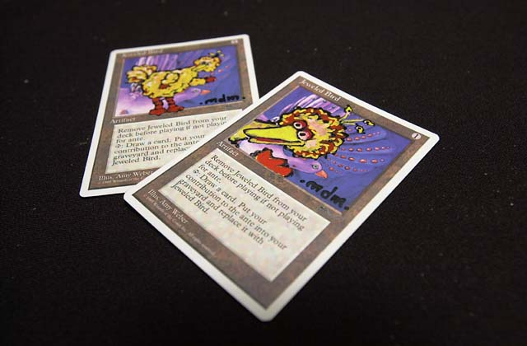
Kurtis Hahn, who was trying to find use for many mediocre rares sitting in his binder, invented it. The format is enjoyed by casual and competitive players both - two players in a middle of a 5C game often draw a crowd anywhere from a local store to the Pro Tour. Randy Buehler is a big fan and a staunch supporter of the format - which I suspect has helped it become chosen to be used at the Invitational.
New question:Jon Finkel's card Shadowmage Infiltrator was printed in Odyssey. What card did Jon originally submit at last year's Invitational?
Please do not email me your answers. The correct answer will be posted in next week's column.

Bad Play of the Week
A lot of people emailed me to correct me about the previous bad play of the week. Although I was aware of the ruling myself, I phrased it in such a way that some readers may not have fully appreciated just how bad the play was. In fact, the caster of Bribery could simply choose to find nothing rather than to put his opponent's Desolation Angel into play. Sorry for the confusion.
As always, please send good/bad plays, cool trivia questions, and other news to NEW ADDRESS: ashv80@hotmail.com.

